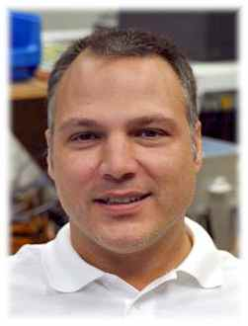
Curriculum Vitae

Schooling and Professional Training

23/04/1996 Graduated with a Master’s level degree in Mechanical Engineering (University of Applied Sciences)
Since June 1996 Self-employed and proprietor of Brand Consulting Engineers

Computer Expertise in: MS Office, simulation software, programs for creating CAD 3D constructions, AutoCAD 2D and 3D, Inventor, Internet and web design, CorelDraw, databases, MS Office, graphics and design.

Projects
completed,
overview Experience accumulated by working for such customers as: Pretema (Tyco) Pforzheim, Hanover Airport, Nukem Frankfurt, FES Frankfurt, Frankfurt Airport, Karlsruhe Research Centre, consulting engineers for mechanical engineering projects and plant construction.
Projects completed there: Construction of automatic palletisers, remote-controlled vehicles, waste disposal machinery and compactors, heavy goods vehicles, robotic arms, plants and containers for liquefied gases, cryogenic engineering sensors, stress calculations, handling systems, woodworking machines, fuel tank processing equipment, rectification plants in the field of applications involving radioactive tritium and deuterium, flow diagrams for refrigeration plant schemes, the creation of R&I schemes (MSR technology).
Project management abroad: Spent 6 weeks as a supervisor in Moldova, EFES Brewery.

Details of
experience Twenty years’ professional experience in canvassing new business, purchasing, sales, sales marketing, calculation and project management in mechanical engineering and electrical engineering. Experience and day-to-day contact with DIN EN standards. Familiar with patent search techniques. Special expertise in sensor technology, frequency converters, linear electric/pneumatic drive technology and automation. Involved with terms such as cost and progress tracking, purchasing, worldwide distribution, cross-financing, preparing quotes, placing orders, and work scheduling and production tracking. Special expertise in the field of regenerative energy, principally as regards wind power, PV systems and solar thermal power.

Languages English, both verbal and written.

Positions held - Chairman of the Executive Board, StarInvention AG (1996-2012)
- Since 05/2014 CEO of Sunesty, LLC., USA

